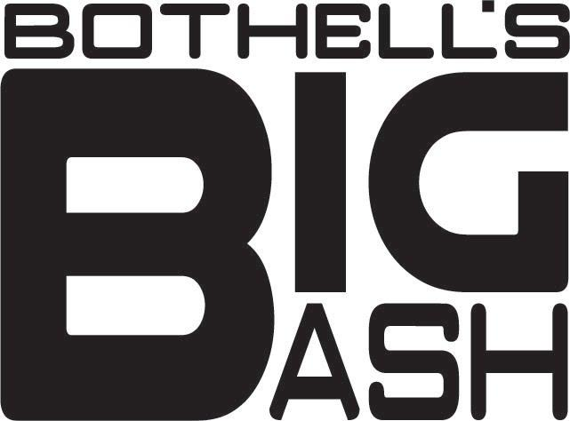

October 2018

Dear Bothell Business Owner,

We are writing to ask you to join our Community Cares Campaign showing our graduating seniors of Bothell High School that we care about their safety on graduation night! We are asking for your support of Bothell’s Big Bash, the All-Night Senior Grad Party for the graduates of Bothell High School held the night of graduation June 18th, 2019.

While Bothell Big Bash is a self-funded Bothell High PTSA Event, it is not a school sponsored event. The party is planned and funds to help support the event are raised through ticket sales and by the parents and seniors of the graduating class. We do this because this event provides our students a safe, sober, supervised and fun place to celebrate their high school graduation with their friends. We want to make sure that all the time, energy and education that has been invested in these young people’s lives is not wasted on one foolish accident. Statistics show that students celebrating on the evening of graduation can experience one of the most dangerous nights of their young lives. It is our goal to keep as many of our graduates as safe as we can.

This is why, as senior class parents we are organizing this structured, fun event with entertainment all-night-long—keeping them off the streets and away from any temptation all while having an amazing time celebrating this milestone. The All-Night Big Bash begins with organized bus transportation from BHS on graduation night, traveling to surprise destinations with incredible entertainment, food and music, returning our graduates safely back to BHS early the next morning.

We are in need of your help to make sure this event is a total success. We hope you will support us in our efforts to create this over the top experience for our graduates by making a financial donation. We think it’d be fantastic if you or your local business became a Community Cares Partner and would make a tax-deductible donation.

I think all of us can agree that this party is more than just a party. This is a fun way for the entire Bothell community to let our graduating senior know that we care about their future, that we want them all to make it through their graduation night accident free.

We hope that you will choose to help us out this year. Our goal is to raise over $6,000 to help with the cost of transportation and provide as many scholarships as possible to keep all our graduates safe. Truly we appreciate any help you can give. Your donation along with the attached donation form can be mailed directly to Bothell High School,
C/O BHS PTSA Bothell’s Big Bash, 9130 NE 180th St., Bothell WA 98011 or call Vi Noel, 206-999-1661 and we can make arrangements to pick it up. Bothell High PTSA is a 501c3 non-profit and your donation may be tax deductible. Tax ID # 91-1043336.

Thank you for your generosity!

Vi Noel and Laurie Ferraiolo
Co-Chairs Bothell’s Big Bash Class of 2019
Contact Cell # (206)999-1661
Email: bash@bhsptsa.com

